**Ammonia Gas Sensor (NH3)**

Sensitive material of MQ137 gas sensor is SnO2, which with lower conductivity in clean air. When NH3 gas exists, the sensor’s conductivity gets higher along with the gas concentration rising. Users can convert the change of conductivity to correspond output signal of gas concentration through a simple circuit. MQ137 gas sensor has high sensitivity to NH3 gas, also can monitor organic amine such as trimethylamine, chloramine well. It can detect kinds of gases including ammonia and is a kind of low-cost sensor for kinds of applications.

COST= Around 2000/-

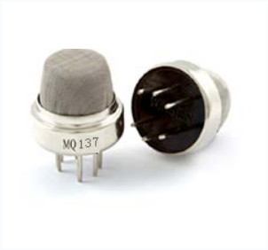

**CARBON MONOXIDE Sensor (CO)**

The gas sensing material used in the MQ-7 gas sensor is tin dioxide (SnO2), which has low conductivity in clean air. When carbon monoxide gas exists in the environment where the sensor is located, the conductivity of the sensor increases with the increase of carbon monoxide gas concentration in the air.

COST= 100/-

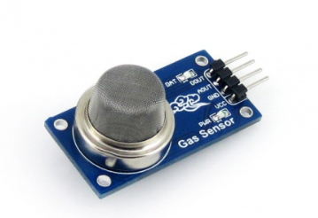

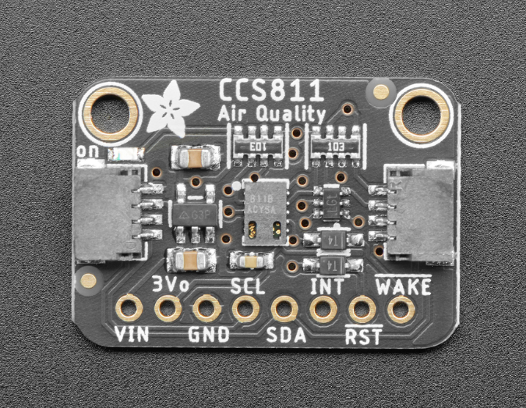

 This sensor from AMS is a gas sensor that can detect a wide range of Volatile Organic Compounds (VOCs) and is intended for indoor air quality monitoring. When connected to your microcontroller (running our library code) it will return a Total Volatile Organic Compound (TVOC) reading and an equivalent carbon dioxide reading (eCO2) over I2C

COST- around 2000/-

**CCS811+BME28 (Multi-Function Environment Module)**

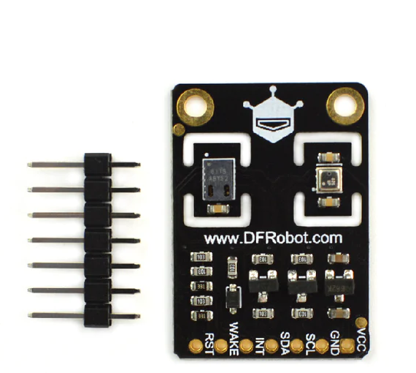

The BME280 can provide temperature and humidity compensation for CCS811 to improve the whole accuracy to a certain extent. It can be used to detect temperature, humidity, barometric pressure, altitude, TVOC, and eCO2.

CCS811 air quality sensor uses AMS's unique micro-hot plate technology. Compared with conventional gas sensors, it has lower power consumption, shorter preheating time, and smaller size. The internally integrated ADC and MCU allow it to collect and process data, and return via I2C.

BME280 is an environmental sensor that combines temperature sensor, humidity sensor, and barometer in one board. It has high precision, multiple functions, small size, etc. The sensor offers ±0.5℃ temperature error and ±2%RH humidity error.